Regional Development Australia - An Australian Government Initiative

mid north coast

Media release

Post-Secondary education comes to Norfolk Island

February 2025

Regional Development Australia Mid North Coast (RDAMNC) is thrilled to share that the Australian Government has announced the establishment of a new Regional University Study Hub for Norfolk Island. This project will be led by RDAMNC, marking a significant milestone in providing university-level and other post-secondary education to the residents of Norfolk Island for the first time in history.

*Assistant Minister for Education and Regional Development Anthony Chisholm welcomed the announcement, stating:*

“Each time we open a new hub in a regional, rural or remote community, we’re removing an educational barrier that can stop people from getting a tertiary qualification.”

The barriers to access for post-secondary education include an international flight and a communications system that shows you as living in Antarctica.

The creation of the Country University Centre on Norfolk Island offers incredible opportunities for Norfolk Island residents. For the first time, young people on the island will have access to university-level education without needing to leave home. This means that there is access to any Australian tertiary education institution and not just a single affiliation with one university.

Additionally, residents who are looking to seek an alternative career pathway into trades and other vocational education training (VET) opportunities will also be able to utilise this facility to undertake the study components of their courses.

The CUCNI will be a space that provides supported learning for all tertiary, VET and senior school students completing their Higher School Certificate (HSC). It also presents opportunities for career changes and further education for mature-aged students, allowing them to study in their own community and close to their support networks.

Whilst this is a Government funded opportunity, the CUCNI has been established as an independent charity in its own right and is community-led by local residents, supported by RDAMNC and the Country Universities Centre network. The CUCNI Board is excited about the new opportunities the hub will bring to the community. The Board members include David Buffett (Chair), Sharon Nicol, Mary Christian-Bailey, Margaret Christian, Gaye Evans, Susan Prior, Chris Ronan (CUC), and Madeleine Lawler (RDAMNC). Together, they are committed to supporting the growth and development of education on Norfolk Island, ensuring that residents can access the same educational opportunities as those in Australia.

Work has already begun on Norfolk Island, with RDAMNC CEO Madeleine Lawler and COO Dianne Wall travelling to Norfolk Island to work with the CUCNI Board to commence the establishment of the CUCNI.

RDAMNC is looking forward to continuing to work with the CUCNI Board to bring this vital opportunity to the community and it is hoped that the centre will be open in September 2025. Further updates and opportunities for community engagement will continue throughout the year.

*Country University Centre Norfolk Island (CUCNI) Chair David Buffett applauded the announcement, stating:*

“Norfolk Island has been passionate about education from its founding in 1856. Children had access to primary education universally. However, the secondary years 11 and 12, took decades to achieve. Now the Country University Centre for Norfolk Island represents the next significant educational advancement for our community. There were no local options for post high school education and once we've finished the fit out of the CUCNI, all Norfolk Islanders can be educated in traineeships, trades or university right here on our Island home”

*RDAMNC CEO Madeleine Lawler states:*

“Accessing education from a tiny island in the Pacific Ocean, 1600km off the coast of Brisbane is shortly going to be a reality. We see this as a game changer for the local community, the options for young people and the community’s ability to ‘grow their own’ in terms of workforce and opportunities. RDAMNC couldn’t be more proud of its role in supporting this initiative. Saying we’re excited is an understatement. We have been able to work with the long-term champions of education and advancement to bring this into reality. I can’t wait to see what the community does with this new opportunity.”

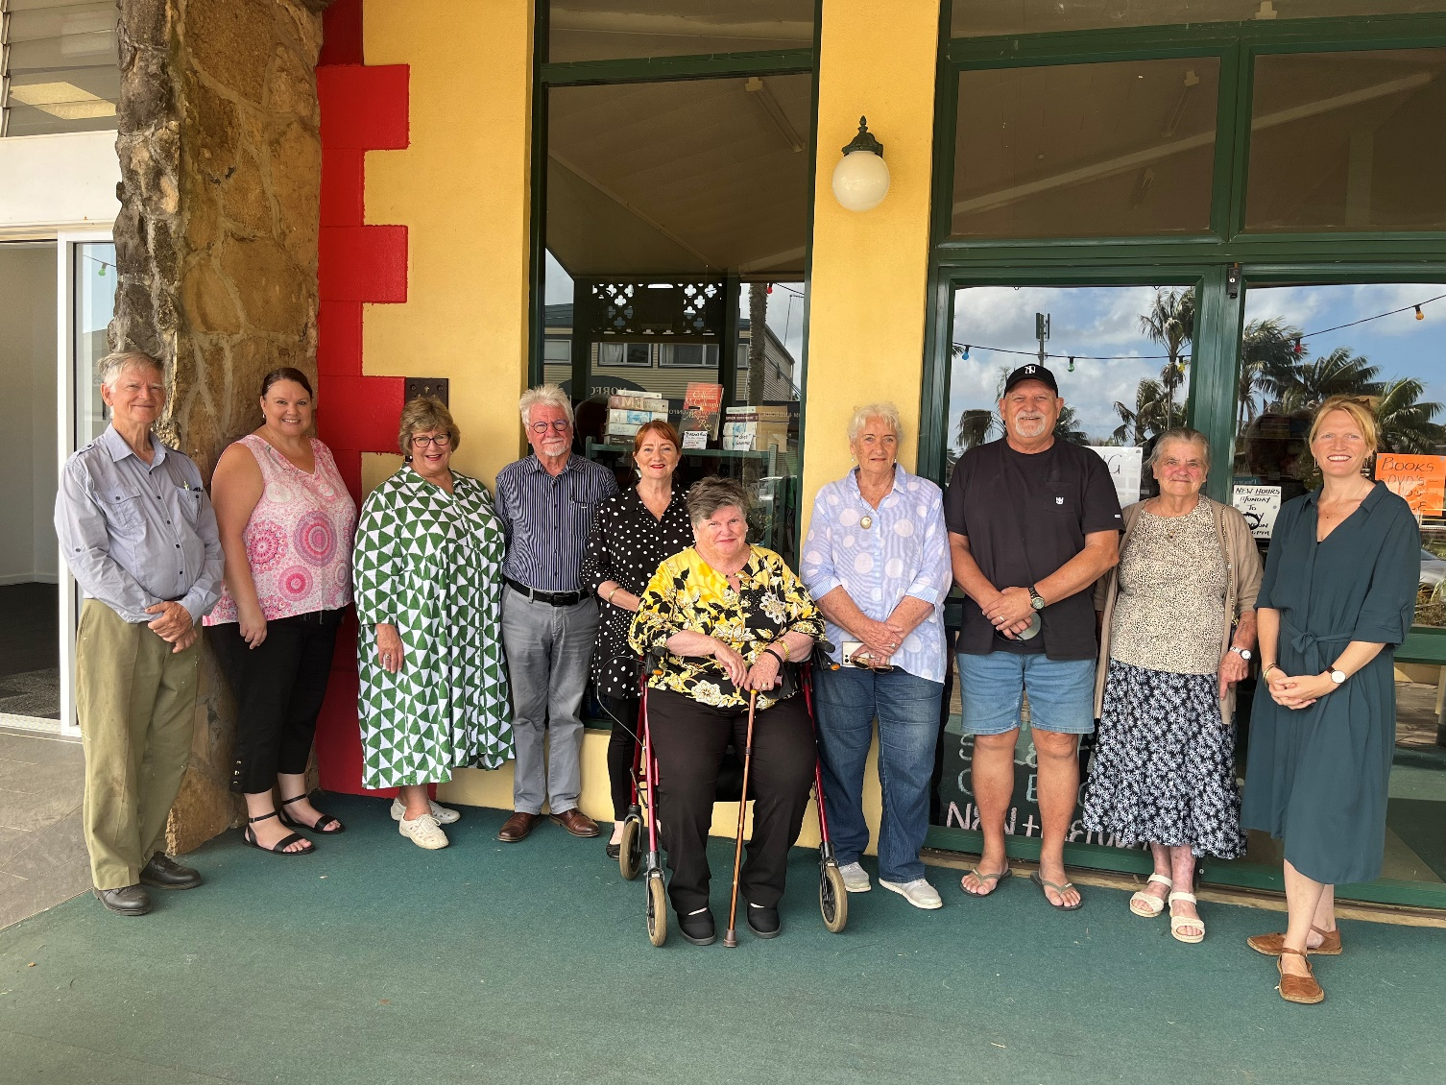

CUCNI Board Members are pictured with RDAMNC representatives and owners of CUCNI site, Geoff and Wallis Edwards.

**ENDS**

For additional information, please contact:

Media contact

Dianne Wall

Chief Operations Officer

T: 02 5525 1500

E: [operations@rdamnc.org.au](mailto:operations@rdamnc.org.au)